HIGHLAND SCHOOL

PARENT/STUDENT
HANDBOOK
and
DISCIPLINE POLICY
2022-2023

Highland School
801 Central Ave. N.
Crookston, MN 56716
(218) 281-5600
(218) 281-6166 Fax
WWW.CROOKSTON.K12.MN.US

THIS
PAGE
LEFT
BLANK
INTENTIONALLY

Highland School
Grades 1-6
801 Central Avenue North
Crookston, MN 56716
218-281-5600

Principal Chris Trostad
(christrostad@isd593.org)

Jana Hodgson, Administrative Assistant
(janahodgson@isd593.org)

Crystal Rock, Administrative Assistant
(crystalrock@isd593.org)

Board of Education

Frank Fee Chairperson
Patty Dillabough Director
Dave Davidson Director
Mike Theis Director
Tim Dufault Treasurer
Adrianne Winger Clerk

“It Starts With Me!”
ISD 593 Employee Core Values
Communication: Crookston Public Schools will excel in communicating with students, parents, staff, and community.

A Culture of High Expectations: Crookston Public Schools will be a place in which high expectations are set for our students and staff.
Relationships: Crookston Public Schools will excel in building strong relationships with students, families, staff, and community.
Exceptional Systems of Support: Crookston Public Schools will provide a strong system of mental health and academic support for students and families.

Web Site

More information about our schools can be found at www.crookston.k12.mn.us.
Click on “Schools” and follow the links!

Highland School

Chris Trostad, Principal
Highland School
801 Central Ave. North
Crookston, MN 56716

Welcome to Highland School

On behalf of our school staff, we welcome you to the 2022-2023 school year. Highland serves students in grades one through six. Our school day begins at 8:00 am and ends at 3:00 pm.

The general guidelines, policies, and procedures for Highland School are included in this handbook. We encourage you to review this handbook and call if you have any questions.

We are looking forward to working with you and your children this school year!

Sincerely,

Chris Trostad

Chris Trostad
Highland School Principal

TABLE OF CONTENTS
Attendance Policy page 7
Bicycles, Skateboard & Roller Blades page 8
Breakfast & Lunch Program page 8
Building Usage page 8
Bullying…………………………………………………………………………………… .page 8
Cell Phones………………………………………………………………………………. page 8
Change of Address page 9
Classroom Visitation page 9
Communication page 9
Conferences page 9
Data Privacy page 10
Discipline Policy page 10
Doctor/Dental Appointments page 10
Dress Code page 11
Emergency Information page 11
Extra Help page 11
Face Masks……………………………………………………………………………….page 11
Family Services………………………………………………………………………….page 12
Fidget Devices ………………….……………………………………………………… page 12
Field Trips ………………………………………………………………………………. page 12
Fire/Disaster Drills page 12
Head Lice……………………………………………………………………………….. page 13
Homebound Instruction page 13
Homework. .................................................................. page 13
Illness During School .......................................................... page 13
Immunizations page 13
Incomplete Work page 13
Lockers page 14
Lost & Found page 14
Medication page 14
Minnesota Comprehensive Assessments page 14
Music page 15
Parent/Teacher Organization (PTO) page 15
Items Not Listed on Classroom Supply Lists page 15
Parking page 16
Pets page 16
Phones………………………………………………………………………………… page 17
Recess page 17
Report Cards page 17
Restraining Orders page 18
School Nurse page 18
School Messenger………………………………………………………………………page 18
Sexual Harassment & Sexual Violence page 18
Special Services page 18
Storm Policy page 18
Student Placement Requests page 19
Tennis Shoes page 19
Volunteer Help page 19
Weapons page 19
Wellness Policy page 20
Withdrawals from School page 20
Appendix A: Student Transportation Services & Bus Regulations page 21-23
Appendix B: Pest Control Notice page 24
Appendix C: Highland School Arrival & Dismissal Schedule page 25
Appendix D: Highland School Lunch & Recess Schedule ……………….……..... page 26
Appendix E: Highland School Schedule (Normal) ………………...……………... page 27
Appendix F: Highland School Schedule (Late Start) …………………...…….…. page 28
Appendix G: Map of Highland Parking Lot ………………………..……...……....... page 29
Appendix H: Highland School Discipline Policy …………………………...…… page 30-33
Appendix I: Parent Refusal for Student Participation in Statewide Testing…..page 34-36
Appendix J: 2019-2020 Highland School Calendar ….....………....................... page 37
Appendix K: Student Placement Request ….....………....................... page 38-39
Appendix L: Medication Administration Authorization Form….....………..............page 40
Appendix M: School Volunteer/Chaperone Form……………………………………page 41

ATTENDANCE POLICY
Parents and guardians are responsible to see that their children attend school daily and on time. Students must be in school each and every day for each and every hour of the day unless they are ill, have a medical appointment or experience a family emergency. When a student is absent, parents should call the school by 8:00 A.M. This lets us know that the child is safe and that there is a reason for him or her to not be in school. Daily, our office staff attempts to contact each family whose child is absent, if the school has not been notified. If your child arrives late to school, they are required to report to the office if arriving after 8:30am. Students that are “continuing truant” or “habitually truant,” including cases of chronic tardiness, will be referred to our school’s discipline guidelines.

There are two types of absences:
Excused: Excused absences include illness, medical appointments and family emergencies. A doctor’s statement may be required after three or more consecutive absences or a pattern of absences due to illness. The administration will decide if the absence is excusable based on the reasons given. If your child has an appointment during school hours, please bring a note from the appointment to ensure this time away from school is an “excused” absence.

Unexcused: Unexcused absences are those that could have been reasonably avoided or delayed. (Examples include, but are not limited to: oversleeping, shopping, haircuts, etc.) Even with the consent of the parents, absences can be ruled unexcused by the school administration. Whenever possible, absences should be communicated in advance. When this is not possible, all absences must be cleared through the office within 24 hours of the student’s return to class, or the absence may be declared unexcused. At three unexcused absences, the school is legally required to notify the parent or guardian that the child is a “continuing truant,” and the student may be required to make up the missed school time after school. The school may schedule a meeting with Polk County Social Services and the parents to discuss the student’s attendance.

Each truancy case will be dealt with on an individual basis and will include one or more of the following: student conference, parent conference, involvement with Social Services, and/or detention to make up the time missed.

The Minnesota Department of Education requires students to be in attendance 90% of the school days to have “Consistent Attendance.” Students are “Chronically Absent” when they miss more than 10% of the school days per year. The state of Minnesota includes BOTH excused and unexcused absences toward the 90% in school attendance requirement. When students are on pace for being “Chronically Absent” from school based on a pro-rated monthly calculation Highland School staff will make phone calls to parents/guardians and send letters informing parents when their student is on target for being “Chronically Absent” from school.

Minnesota Statute states that if a child is under 12 years of age and the school has made appropriate efforts to resolve the child’s attendance problems, a child’s absence is legally considered to be the result of the parents’ failure to comply with compulsory instruction laws. This is defined as educational neglect. When seven un-excused absences (non-consecutive) have occurred, the student is considered “habitually truant” and the school is required to file Educational Neglect to Polk County Social Services.

BICYCLES, SKATE BOARDS, ROLLER BLADES, AND SCOOTERS
When a student has reached school property, he/she must remove their roller blades and/or carry their skateboards. Roller blades and skateboards must be stored in lockers or in the office between 8:00 am and 3:00 pm. Bicycles must be stored in the bicycle racks between 8:00 am and 3:00 pm. Failure to follow school rules regarding roller blades, skateboards, and bicycles will result in a loss of privileges and they will not be allowed on school property. Scooters are not allowed at Highland School. At Highland, skateboards and roller blades may not be used on school sidewalks or on the playground for safety reasons. Students wanting to leave before the buses need to carry their skateboards or roller blades to the bike rack and put them on. Tennis shoes with wheels in them are not allowed in the buildings. Remove the wheels and store them in your locker. Encourage your student(s) to place these items in a locked locker once they have reached school. Highland School is not responsible for lost, stolen, and/or damaged skateboards, rollerblades or bicycles.

BREAKFAST AND LUNCH PROGRAM
Breakfasts and hot lunches are served daily. The Crookston Public Schools Hot Lunch Program is part of a federal and state program whose policy allows families in certain income brackets to have lunches served free or at a reduced cost. To apply for free/reduced meal prices, request an application from the school or district office. Payment for school lunches should be made in advance at each school.

Cold lunches may be brought from home. Milk is available for purchase to accompany a cold lunch. We discourage students from bringing pop or energy drinks along with cold lunch. We encourage parents and siblings to join us for lunch any day of the week. Parents or family members may have lunch with your student only. Please sit at the designated guest table.

BUILDING USAGE
The Board of Education has an established policy and fee schedule for groups desiring to use the building before or after school, weekends, or during the summer. Please contact the office for the schedule and building request forms.

BULLYING PROHIBITION POLICY
Highland School will follow the district handbook according to Policy 514. You are able to view the current policy at http://www.crookston.k12.mn.us/sites/crookstonpublic.new.rschooltoday.com/files/policy_514_-_bullying_prohibition.pdf

BUSING
Busing additions/changes can be made through the Bus Garage 218-281-5444.
Parents can request their student to be escorted to their bus after school.

CELL PHONES
See “Phones.”

CHANGE OF ADDRESS/TELEPHONE OR CELL PHONE NUMBER
It is the responsibility of a parent or guardian to notify each school of any changes in address, telephone or cell phone numbers. For your child’s safety, please notify the school each time there is a change, so we are able to contact you in the event of an emergency or illness.

CLASSROOM VISITATION
Parents have the right to view the curriculum of their child’s teacher. Due to student confidentiality, parents are NOT allowed in classrooms unless approved by the Principal. Students are not to bring friends or relatives to visit during school hours, unless the principal grants permission. Anyone entering the school MUST report to the office to sign in and pick up a visitor’s pass.

COMMUNICATION
The staff wishes to communicate with families on a regular basis. It is the goal of the entire staff to keep families and all residents of Independent School District #593 informed of the activities and many interesting and worthwhile events throughout the District. In addition to phone and email communication, teachers may send home newsletters or share information on their website. Families may also get information on student attendance and grades using the online Skyward system. Contact administrative assistant Jana Hodgson to set up an account. District employee’s email addresses follow this general format: firstlast@isd593.org.

Parents that would like to meet with the Principal need to make an appointment with the Highland Administrative Assistants due to the Principal’s scheduled appointments and to ensure he is available. Please call 218-281-5600.

CONFERENCES
Parent/Teacher Conferences are scheduled in the fall and spring. Conference schedules for elementary students are sent to each home prior to the conference period. Additional conferences will be scheduled as needed by parent or teacher request. Parents also can call for a phone conference during the teacher’s preparation period and before or after school. Conferences can be schedule online through Skyward website or the Skyward Family Access App.

DATA PRIVACY
The policy on Data practices and the procedures included with it are designed to meet the provisions of the Family Educational Rights and Privacy Act (FERPA), the Minnesota Government Data Practices Act and the Confidentiality of Information section of the Education for All Handicapped Children Act of 1975. The Crookston Public Schools are committed to implementing the policy and following the procedures.

The Board of Education authorizes the school Superintendent to inform parents, students and the public of the policy and to exercise his administrative resources to implement the policy as well as deal with individuals who violate it.

In case the parent of a student, an eligible student or a citizen of the Crookston Public Schools believes that the district is violating the intent of the above legislation and is not able to resolve the issue with School District personnel, questions or problems may be directed to:

1. Information Policy Analysis Division
MN Department of Administration
201 Administration Building
50 Sherburne Ave.
St. Paul, MN 55155
(612) 296-6733 or 1-800-657-3721

2. Family Policy Compliance Office
US Department of Education
400 Maryland Ave. SW
Washington, DC 20202
1-800-872-5327

DISCIPLINE POLICY
Our discipline policy is designed to promote a positive environment for learning. The atmosphere of the school is intended to promote fairness, honesty, and respect among students, school personnel and community members. The discipline plan is intended to help students learn and practice appropriate behavior throughout the common areas of the school as well as in their classrooms. The common areas of the school are the hallways, bathrooms, library, lunchroom, playground, bus lines, etc. Each classroom teacher has a general classroom discipline plan.

It is the responsibility of every student to respect and follow the general rules of the school. When students choose to act disrespectfully and not follow the rules, the student may be required to sit out of recess, or receive other consequences that include, but are not limited to, suspension or expulsion. Specific examples of inappropriate behavior include fighting, bullying, threatening to kill another student and disrespectful or threatening language or gestures.

Highland School Rules and Expectations Include:
- Do the right thing
- Do it to the best of your ability
- Treat everyone with dignity and respect

See Appendix I for Highland School’s Discipline Policy

DOCTOR/DENTAL APPOINTMENTS
When possible, the school office should be notified in advance of doctor and dental appointments your child will be attending during the school day. On the day of any appointment, please pick up and sign your child out of the office for their appointment. Bring back a note from the appointment to ensure the time away from school will be considered an “excused” absence. Upon return from the appointment, please come into the office to sign your child back into school for the rest of the day.

DRESS CODE
All students are expected to observe a high standard of conduct at school and at all school related functions, in or out of town. High standards of conduct extend to wearing appropriate clothing. It should be neat, clean and in good taste.

The following clothing is not allowed:
- Clothing which violates the rights of others and/or disrupts the educational setting, including insignia and gang related colors, is prohibited in the school setting.
- Students may not wear caps, hats, hoods, jackets, bandanas, or coats in the school. They are to remove their hats/caps/hoods/bandanas when entering the building.
- Students are restricted from any manner of dress or personal grooming which presents a danger to health or safety; causes interference with work; or creates classroom or school disorder. Such clothing includes but is not limited to: clothing with drug, alcohol or tobacco advertising; print or graphics which is sexually explicit or suggestive; representations which are inappropriate, offensive or demeaning to any group; clothing which is suggestive or inadequate in its covering, such as shorts that are inappropriate in length, skimpy tank tops that expose the midriff such as shirts with spaghetti straps; and pants worn below the waist.
- Shorts/skirts must be an appropriate length.

Consequences for violating the dress code include but are not limited to:
* Change of clothing immediately
* Removal from class
* Parent Conference

Proper footwear is also required. Slippers or stocking feet can be dangerous and/or disruptive in the classroom. During cold weather, students should wear warm clothing such as jackets, hats, mittens, snow pants, and boots. Boots will NOT be permitted to be worn in school during class time. Physical Education teachers encourage all students to have good fitting, lace-up tennis shoes for class. These shoes help prevent accidents and injuries.

EMERGENCY INFORMATION
Parents/guardians must complete the emergency information portion of the student enrollment form each year. This emergency information will include the name of a responsible person who can be contacted if a parent/guardian is unavailable. This is useful in case of illness, accidents, early dismissal due to weather, or other unforeseen events. The school offices must be notified of any changes in address, telephone or cell number, employment location, or designated emergency contact.

EMERGENCY SITUATIONS
In the event of a school-wide emergency parents would receive an Instant Alert message telling them what location to go to receive information regarding the situation or to pick up their child. Parents are not to come to Highland School in the event of a school-wide emergency because it will hinder emergency personnel. Parents are to meet at the designated location stated in the Instant Alert.

EXTRA HELP
Students may seek extra help from their teachers if they do not understand an assignment, if the work is difficult, or if they have missed school. Students should talk to their teachers to arrange a time during the day, before school, or after school to get extra help. A teacher may sometimes request that a student stay after school if it is apparent that the student is having difficulty with the work. This should not be thought of as punishment, but rather as the desire of the teacher to help the student achieve academically.

FACE MASKS
Optional

FAMILY SERVICES/COUNSELOR
A School-Based Mental Health Provider & Counselor are available to families and students at Highland School. Services are available to support families and can include mental health services, school supplies, cold weather gear, referrals/connections to resources within the community and homeless liaison services. For more information about services available please contact Tara Rodriguez, Jenna Sullivan or Kris MacGregor.

FIDGIT DEVICES/LASER POINTERS
The use of fidget devices (fidget spinners, fidget cubes, etc.) are allowed but only in classrooms where the teacher has approved their use. They are not to be used outside of that teacher’s classroom. Students who violate this policy will have their fidget device confiscated.

Laser pointers are not allowed to be on school property. If a student violates this policy it will be confiscated and parents will have to pick it from the school.

FIELD TRIPS

Any parents that are interested in chaperoning a field trip must complete a Volunteer/Chaperone form in the office. You can also find the required form in Appendix N of this handbook. Chaperones must return the form to the Highland School office one week prior to the field trip. The office will notify you if you are needed as a chaperone on the field trip. Only approved chaperones will be allowed to go on field trips. Chaperones must be parents or guardians of a child on the trip. Parents or guardians must have legal parental and custodial rights to that child to chaperone. Chaperones will be limited due to space limitations on busses.

The Principal will make the decision if a student will NOT be allowed to attend a field trip or all field trips. The reasons for students losing field trip privileges may include but are not limited to the following:
- Leaving school without permission;
- Law enforcement assistance with your child;
- Students that have had drug, alcohol, tobacco, destruction of school property, assault, or weapons violations; and
- Other discipline related offenses as determined by the Principal.

FIRE/DISASTER DRILLS
Ten fire and disaster drills are held during the school year. These drills usually take place in the fall and spring of the year. If our area is under a tornado warning, or lock down, the students will not be dismissed from school until we have an official "all clear" notice.

HEAD LICE
Suspected cases of head lice in school will be referred to health service staff. If students are identified as having live head lice, Health Service Staff (HSS) will notify the child’s parent or guardian by telephone call or by sending a note home with the child prompting parents of proper treatment. Children with lice will not be excluded from attending school whenever possible. They may return to school as soon as they have been treated for live lice. At the discretion of the school nurse, a letter may be sent home to parents in the classroom. The classroom teacher will be notified of the presence of lice in their classroom and encouraged to report any other suspected cases. HSS will check siblings, or notify other schools of the situation where siblings are located, if it is deemed necessary. Staff will maintain confidentiality of students with lice at all times. HSS may check in with the student or parent the next day to insure treatment was done and no live lice are still present. Parents are encouraged to check their children periodically for head lice and be aware that it can be present at any time but does not pose a health risk.

HOMEBOUND INSTRUCTION
Homebound instruction will be provided for students via Distance Learning who will be out of school or at the hospital for an extended period of time, and have a doctor’s statement.

HOMEWORK
Homework should supplement and reinforce what has been taught in the classroom. Some students may need added practice in basic skills that are taught. For other students, homework is a means of enriching school activities. Students who fall behind because of absence or poor work habits may need homework to catch up with their group. It is the school's objective to assign homework to accommodate the needs of a student. If a student has a great amount of homework every day, please arrange a conference with his/her teacher to determine why it is happening.

ILLNESS DURING SCHOOL

If a student becomes ill while at school, a parent/guardian will be notified and requested to come pick the child up. If no parent is available, it is very important that prior arrangements be made with a neighbor or relative to assume temporary care of your child. Please keep your emergency information accurate by notifying the office of any changes. If you have questions or concerns please contact the school nurse at 218-281-5600.

IMMUNIZATIONS
The law requires that all students entering any grade in school must have, on file, or submit a completed Certificate of Immunization signed by a physician, public health nurse, or the parent/guardian as required before they can be admitted to school unless the parent or legal guardian signs a waiver.

INCOMPLETE WORK
Any student who misses school because of an excused absence will be able to make up the work that was missed. The general rule is that for each day of absence, one day will be given to makeup the work. Any student, upon the day of his/her return from the absence, is responsible for any and all assignments and/or any recitations which were assigned previous to the absence and which were due the day of the absence from the class. In cases of extended illness in which students need additional time to make up work, permission must be granted through the principal's office.

LOCKERS
Students are assigned a locker to keep their personal items such as outdoor garments. Students in grades 1-4 may bring a lock from home to use on their locker with their teacher’s permission. If your student chooses to bring a personal lock the combination and/or a second key must be given to the office to keep during the school year before the lock can be used. The reason for this is students often forget their combinations and keys so this will prevent the lock from needing to be cut off of the locker. In the event that a personal lock is cut off of a locker Highland School is not responsible for replacing the personal lock. Locks are provided for 5th and 6th graders. Personal items must be stored inside the lockers at all times with the locker door shut. Do not store items above the lockers or on the floor of the locker bay. Students are not to bring valuables or toys (Items not listed on the teacher supply lists) to school. The school is not responsible for lost or stolen items.

Chapter #227 of Minnesota Statutes covers student lockers. The state-mandated policy is as follows: “School lockers are the property of the school district. At no time does the school district relinquish its exclusive control of lockers provided for the convenience of students. School authorities for any reason may conduct inspection of the interior of lockers at any time, without notice, without student consent, and without a search warrant. The personal possessions of students within a school may be searched only when school authorities have a reasonable suspicion that the search will uncover evidence of a violation of law or school rules. As soon as practicable after the search of a student’s personal possessions, the school authorities must provide notice of the search to students whose lockers were searched unless disclosure would impede an ongoing investigation by police or school officials.”

LOST AND FOUND
There is a Lost and Found area at each school. Anyone who is missing personal items should check there. Fragile or valuable items (e.g, prescription glasses, keys, jewelry) that are found may also be turned in at the office. If the items have not been claimed after one week, the items will be donated. There is also a Lost and Found box at the bus garage (281-5444).

MEDICATION
If your child needs to receive any type of medication during the school day (Including over the counter medication such as aspirin, etc.), the school nurse must have, on file, a permission form signed by the parent/guardian and family physician. These forms need to be updated annually in the case of long-term medication requirements and are available in the school office and located in Appendix M of this handbook. State law prohibits the school from giving medication without a doctor's order. Please keep all medication in the original labeled container. Label must include the student’s name. Students may never possess medication that is not prescribed to them (family members inhaler, etc.) All medication will be dispensed by school personnel. Medication must be delivered to school and picked up by an adult. Students should never provide over the counter medications (Aspirin, etc.) to other students and ALL medications are required to be stored in the office at all times (Never in the student's locker). If a student is found to have medication in their possession without the proper paperwork the parent will be called immediately and the parent will be required to come pick up the medication or complete the required forms.

MINNESOTA COMPREHENSIVE ASSESSMENTS (MCAs)
The Minnesota Comprehensive Assessments measure how well a student has mastered the math, reading, and science standards. Students in grades 3-6 are tested each year in reading and math. Fifth graders also take a science test. Students do not pass or fail these tests. Based on their scores, students are identified as not meeting, partially meeting, meeting, or exceeding the state standards in a given subject. These tests are part of Minnesota’s educational accountability system. Schools will use these results to make curricular and instructional decisions for all students. The tests also provide individual student results and group information about how all children performed. Parents have a right to not have their student participate in state-required standardized assessments. See Appendix J for the Parent/Guardian Refusal for Student Participation in Statewide Assessments form.

MUSIC
Students have the opportunity to participate in orchestra in the spring of 4th grade. Choir and band are offered to students beginning in 5th grade. Concerts are held throughout the year. Musical instruments should be brought to class until your lessons. Instruments should not be left in locker bays, hallways, or stairways leading to music rooms.

PARENT/TEACHER ORGANIZATION (PTO)
Family members, school staff, and other adult members of the community are encouraged to take an active part in PTO. The purpose of the PTO is to foster relationships between the home and school and to support educational programming. PTO meets monthly and adults are encouraged to attend. Notices are sent in advance for meeting dates and times.

ITEMS NOT LISTED ON CLASSROOM SUPPLY LISTS
Any items not listed on the teacher's supply lists are not allowed on school property unless the teacher or principal have made a special exception to this policy. Examples of these types of items would be fidget spinners, rubrics cubes, IPODS, IPADS, handheld electronic devices, slinkys, and etc. Students should not bring personal footballs, basketballs, and etc. to school because Highland provides them for all students.

PARKING

Highland – Morning Drop-Off Routine
It is highly recommended that students are not dropped off prior to 7:45am unless they are approved to be in the Before School Care program.

Enter the parking lot using the east entrance. Drive slowly in one direction by following the painted arrows (see Appendix D for map). You will notice that orange cones are used to block off some of the parking spaces in Row 1 of the lot. If you are dropping off a student, drive past the cones in Row 1 to enter the “Drop-Off Area.” Pull ahead as far as you can in the designated area before letting your student out of the vehicle. Students should exit the vehicle on the passenger side and walk directly to the sidewalk to remain safe. Please show courtesy to others by having your student exit the vehicle once in the “Drop-Off Area.” Do not wait for those ahead of you to finish dropping off a student so that your student can be dropped off closer to the school building unless there are special circumstances (e.g., child is on crutches or carrying a large instrument). During busy times, you may have to wait a short time before entering the “Drop-Off Area” because of the number of cars in front of you. In order to keep your child safe, please do not let your child out of the car until you are in the “Drop-Off Area.” Once your child is safely dropped off, continue to drive through the lot until you reach the exit. Parents or guardians should never be on their cell phones while driving through the parking lot for the safety of students and staff walking through the parking lot!

If you prefer to not wait in line to enter the “Drop-Off Area,” you may park your car in an open spot in Row 1. Once you are parked, your child can exit the vehicle and quickly get on the sidewalk. If using this option, we ask that you use extreme caution when backing out of your parking spot. There may be other cars using the driving lane. We want to keep our students AND our families safe!

After School Pick-Up
Enter the parking lot using the east entrance. Drive slowly in one direction by following the painted arrows (see Appendix D for map). Families must park in Row 1 next to the sidewalk that runs along the fence. In the afternoon, we will not allow vehicles to idle in the “Drop-Off Area” or allow students to enter vehicles that are not parked. There are simply too many cars coming at once and it will not be safe enough. Once you are parked, your child will be allowed to walk down the sidewalk and enter the vehicle. If there isn’t a parking spot available in Row 1, please “circle” around the parking lot until a spot opens up. You can also park in Rows 2, 3, or 4, then you are required to exit the vehicle and walk to the sidewalk to escort your child across the lane of traffic to your vehicle. Parents will not be allowed to enter the building at the end of the day to meet their child inside the building.

Other Highland Parking Notes
- For safety reasons, only buses are to use the bus lane in front of the school from 7:30-8:15 am and 2:45-3:15 pm.
- When a student is late to school or being picked up or dropped off during the day due to an appointment, vehicles may park across from the bus lane (between 8:30 am - 2:45 pm). NO CARS ARE ALLOWED TO BE PARKED IN THE BUS LANES AT ANYTIME! Please call the office at 218-281-5600 to notify the office that you have arrived with your child. Parents then escort their child to the front door without entering the building and a staff member will meet you at the front door to get your child. Children will be screened and if your child does not meet the screening requirements they will be required to return home.
- If you need to park for longer than 5 minutes during the school day (e.g., attend a meeting, volunteer in the classroom, eat lunch with your child), use the parking lot instead of the lane across from the bus lane.

PETS
Family pets are not allowed on school grounds or classrooms at Highland School. The factors that led to this include unpredictable animal behavior, allergies, asthma, and diseases such as rabies. Photos of pets are an acceptable method of sharing a pet. Animals used in therapy, service situations, or for educational purposes may be allowed in our schools if approved by the School District and they meet all policy requirements. If anyone enters the building with a service animal, they may be asked what tasks it performs and if it is a service animal. If it is not a service animal and/or does not perform service animal functions, the animal will not be allowed in our building.

PHONES, HANDHELD ELECTRONIC DEVICES, CELL PHONE WATCHES, ETC.
We ask that parents would please leave word with the school secretary or leave a voice mail message on the teacher’s phone if they wish to have a teacher call them. If parents or guardians need to have an urgent message delivered, office personnel will take the message and see that the student receives it. Students are permitted to use the school telephone only when emergency conditions exist and must have approval to do so from their teacher and the office staff. All arrangements for a student's after school activities should be made before the student comes to school.

Cell Phone Policy: All cell phones must be turned off and kept in backpacks and/or lockers while on Highland School property. They must not be visible. Students may not use their cell phones, handheld electronic devices, cell phone watches, any other electronic communication device between the hours of 7:00 am and 3:30 pm on School property. Students may not use their cell phones on buses.

If a student is using a cell phone (ANY OF ITS FUNCTIONS) for any reason during the restricted time, the following consequences may be imposed:

- Phone will be confiscated from the student
- The discipline policy will be implemented
- The cell phone will be returned ONLY to the parent/guardian of the student. The student, sibling, neighbor or relative other than the parent/guardian may not pick up the phone.

We realize that having to pick up a student’s phone may be inconvenient and therefore we recommend you discuss this policy with your student in order to avoid this problem. We also ask you to keep in mind that the use of cell phones are not only disruptive in class, they are an inconvenience to teachers and staff that must stop what they are doing to correct the problem, label the phone and be responsible for its safe keeping. Confiscated phones will be labeled with the student’s name and kept in the main office until the parent or guardian takes possession. Parents may consult with the Principal should there need to be a reason for a student to have a cell phone outside their locker. The Principal may grant exceptions based on specific individual needs of students.

CROOKSTON PUBLIC SCHOOLS ARE NOT RESPONSIBLE FOR LOST, STOLEN, OR BROKEN CELL PHONES AND WILL NOT PAY FOR PHONES THAT ARE LOST, STOLEN OR MISPLACED.

RECESS BEFORE LUNCH & RECESS BEFORE SCHOOL
Before noon lunch students will go outside to the playground for recess. In case of inclement
weather (snow, rain, excessive wind, etc.), students will stay in for recess. Highland students will be kept inside for recess if the actual air temperature is below -2 degrees Fahrenheit or colder or the wind chill exceeds -10 degrees Fahrenheit or at the discretion of the Principal based on inclement weather. If a child has a health problem (such as a cold or earache) which requires him/her to stay indoors, a note MUST be sent to the classroom teacher requesting that the student stay in at recess. Over the recess period, no student is to leave the school grounds unless accompanied by a parent or guardian and signed out in the office. Students that do not follow recess rules will lose recess privileges for 1-5 days for the first offense, 1-3 weeks for the second offense, and possibly the rest of the year for any further offenses.

REPORT CARDS
Each student's progress is reported through quarterly report cards and Parent Teacher Conferences. Students will receive report cards four times throughout the year. The final report card is mailed to the home approximately one week after school is dismissed.

RESTRAINING ORDERS/ORDER FOR PROTECTION/CHILD CUSTODY
If you have a restraining order, order for protection, or child custody documentation from the court it is your responsibility to provide a copy to the school office as soon as possible. The school district will only follow court documentation issued by a judge not verbal instructions.

SCHOOL NURSE
The school nurse is scheduled to be at each school during the week. The nursing program consists of two aspects: (a) preventive medicine and (b) immediate care in the form of first aid. Students are required to have a pass from their teacher to see the nurse. We understand in emergency cases that is not possible and therefore not required. The school nurse conducts a complete test of vision, hearing screening, and related health activities during the year. The school personnel handle most immediate first aid concerns with assistance from the school nurse. Illness and accidents will be reported to a parent or guardian. In the event of an injury to the head, the parent or guardian will be notified as soon as possible to inform them of the injury and determine whether the child may require additional medical attention. If it is necessary for an ambulance to be called, permission from the parent/guardian will be obtained, if possible. Several staff members are trained as First Responders in the event of an emergency.

SCHOOL MESSENGER
In our effort to improve communication between parents and school, Crookston Public Schools has implemented a telephone broadcast system that will enable school personnel to notify all households and parents by phone within minutes of an emergency or unplanned event that causes early dismissal, school cancellation, or late start. The service may also be used from time-to-time to communicate general announcements or reminders. This service is provided by School Messenger, a company specializing in school-to-parent communications. If you are not receiving school notifications and would like to be part of this service, please contact the school offices to update your information so messages can be sent to your home phone or cell phone.

SEXUAL HARASSMENT AND SEXUAL VIOLENCE
It is the policy of Independent School District #593 to maintain a learning and working environment that is free from sexual harassment and violence. Sexual harassment consists of unwelcome sexual advances, requests for sexual favors, sexually motivated physical conduct or other verbal or physical conduct or communication of a sexual nature.

Sexual harassment may include but is not limited to: verbal harassment or abuse; subtle pressure for sexual activity; inappropriate patting or pinching; intentional brushing against a student’s or an employee’s body; and any sexually motivated unwelcome touching.

If a student is being harassed contact the building principal, teacher or another adult to report this. An oral or written report regarding the sexual harassment will be completed and forwarded to a Human Rights Officer (Jeremy Olson, Superintendent or Kathryn Stronstad, Special Services Director). A Human Rights Officer will investigate the allegation and, if the complaint is valid, the school district will take action as appropriate based on the results of the investigation.

SPECIAL SERVICES
In addition to the regular classroom teacher and related activities, the following programs and services are available: Title I instructional support, English as a Second Language, and Special Education services and testing programs. A parent or classroom teacher can refer students needing these services. Parents desiring more information about these programs may contact their classroom teacher, the building principal, or Kathryn Stronstad, Special Services Director at 281-5313 ext. 2101.

STORM POLICY At times, weather conditions mandate that school be dismissed early or for school not to be held at all. School closings, delayed starting, or early dismissal will be announced over KROX 1260 AM in Crookston, KVLY, WDAZ, Channel 3 of Crookston’s cable television, and through our SchoolReach system (telephone, text, email). Reports will be made between 6:00 a.m. and 7:30 a.m. If no report is made, it can be assumed that school will be in session. Please do not call the school, as the telephone lines must be kept open for emergencies.

STUDENT PLACEMENT REQUESTS
Parents/guardians who wish to make a special request for their child’s classroom placement the next school year must complete the Student Placement Request by Parent form. The form is located in Appendix L of this handbook or in the principal’s office. It must be turned in by April 15th. If you turn in a request and the teachers change you will be contacted to change your student placement request. When requesting a teacher or that your child not be placed in the same classroom as another student (e.g., relative in same grade, neighbor), an educational reason for the request must be listed. Please make your decision based on what is the right fit for your child. Requests will be considered, but cannot be guaranteed. Student placement requests for children that are not your own will not be honored. Administration reserves the right to make the final decision. Student may not switch teachers during the year except for special circumstances approved by the Principal. Changes to another classroom may ONLY take place at the end of a quarter.

TENNIS SHOES
At Highland, all children are requested to have tennis shoes for use in their Physical Education activities in order to avoid accidents. This safety requirement is essential. Choose styles with non-marking soles. Tennis shoes can be a pair worn to school or an extra pair kept at school.

VOLUNTEER HELP
If local, state, or federal guidance states that we are not allowed to have volunteers they will be prohibited.

We encourage parents and other adults to volunteer for various activities or events. These may include classroom parties, field trips, working with students, or other activities that will enhance the educational program. Any parents that are interested in volunteering in a classroom or chaperoning a field trip must complete a Volunteer/Chaperone form. The form can also be found in Appendix N of this handbook. The forms must be returned to the Highland School office one week prior to the field trip or classroom activity, you are volunteering for.

WEAPONS
In this handbook the term "weapon" includes a firearm whether loaded or unloaded, knives, explosives (including fire crackers) or any device designed as a weapon or having the appearance of a weapon (e.g., look-alikes of all kinds) or any device or instrument used or intended to be used to produce death, bodily harm, or injury. Laser pointers are considered a weapon.

POLICY: Possession, use or transmission of a weapon(s) on school grounds, during school time or at school functions including functions held at other locations is prohibited. Violators will immediately be referred to criminal justice or juvenile justice authorities. Minnesota Statute #127.28 mandates that the school board must expel for one year a pupil who is determined to have brought a firearm to school. The expulsion may be modified on a case-by-case basis.

WELLNESS POLICY
The District’s Wellness Policy (#533) exists to promote and protect students’ health, well-being, and ability to learn by supporting healthy eating and physical activity. The policy aims to align the school environment with the health messages that are taught in school. This includes limiting sweet and other unhealthy foods for optimal nutrition and dental health. It also encourages physical activity both in and out of school.

Schools will work toward eliminating the use of food rewards for academic performance or good behavior. Healthy food options will be considered for special school events. Families will be encouraged to support the policy by sending healthy lunches and/or snacks to school. Healthy food options and/or non-food items are encouraged when families choose to send items to school for a celebration.

WITHDRAWALS FROM SCHOOL
If you are moving out of town, the principal or teacher should be notified at least one day in advance so that proper transfer records can be prepared and the child's supplies collected for transfer.

Any items not covered in this handbook will be addressed by the building Principal.

Appendix A: Student Transportation Services and Bus Regulations

SCREENING OF STUDENTS PRIOR TO LOADING THE BUS
All students are required to have their temperature checked and answer COVID-19 screening questions. Should students have a temperature above 100.4 or fail the screening questions the child will not be allowed to ride the bus to school. The student will have to return home. The bus driver will notify the bus garage and parents will be notified.

GUIDELINES FOR ESTABLISHMENT OF BUS STOPS
The Transportation Director will determine the pick-up points and drop-off points for each child being transported and will use the following guidelines:
- It is considered reasonable for students in grades 3-12 to walk up to one-half mile to the bus, except that it shall be reduced to one-quarter (1/4) miles on November 15 and remain in effect until April 1 of each year.
- Students in pre-kindergarten shall be picked up at their door or as close as possible, and students in grades K-2 shall be expected to walk up to one-quarter (1/4) mile to meet the bus, except that it shall be reduced to one-eighth (1/8) mile on November 15 and remain in effect until April 1 of each year.
- It is considered reasonable for in-town students in grades K-12 to walk up to five (5) blocks to a bus stop. Pre-kindergarten students shall be picked up at their door or as close as possible. Carman Terrace, Forrest Knolls and Meadowland students shall be picked up at their entrance.
- Only regularly enrolled students in the public and parochial schools including the Area Learning Center and the Early Childhood and Family Education Program may ride on the public school buses. Drivers are not permitted to pick up adults or others who do not attend the Crookston public and parochial schools.
- Any pupil not regularly riding on a bus will secure written approval from their Building Principal or the Superintendent before riding one of the scheduled bus routes. The written permission shall be presented to the driver before entering the bus.

CONDUCT ON SCHOOL BUSES AND CONSEQUENCES FOR MISBEHAVIOR
Students should be on time at their designated school bus stop and should wait until the bus comes to a complete stop before attempting to enter.

A. Safe Driving Regulations:
While on the bus, students should –
- Never put arms, hands or any other part of the body out of the doors or windows.
- Remember that loud talking and laughing diverts the driver’s attention and makes safe driving difficult. Horseplay, rowdyism or wrestling is not permitted around or on the school bus.
- Not leave their seats while the bus is in motion.
- Be on time at the designated school bus stop to keep the bus on schedule.
- Stay off the road at all times while waiting for the bus.
- Be careful in approaching the place where the bus stops. Do not move toward the bus until the bus has been brought to a complete stop.
- Always be seated when the bus is moving.
- Assist in keeping the bus safe and sanitary.
- Respect and use interior parts of the bus and equipment in the same manner that they treat fine furniture in their home.
- Never leave anything on the bus such as lunch boxes, paper sacks, books or clothing.
- Keep all personal possessions out of the aisles.
- Not throw anything out of the doors or windows.
- Aid in looking after and helping small children.
- Practice courtesy to fellow pupils and offer assistance to the bus driver.
- Remain quiet when the bus is approaching railroad crossings.
- Obey the bus driver instantly in case of an emergency and remain on the bus unless otherwise instructed.
- Demonstrate the traits of good bus citizenship every day. Bus drivers are responsible for maintaining good discipline on their bus.
- Inappropriate language directed at the driver or other passengers will not be tolerated.
- Cellphone use is prohibited.

B. Should discipline problems arise that the driver cannot handle, the following procedures will
be used:

1st Offense:
The bus driver informs the Transportation Services Director of the discipline problem and completes a complaint form. The Transportation Services Director contacts the student’s building principal. The principal calls the parent(s) and sends a letter with a copy of the complaint form and talks to the student.

2nd Offense:
The bus driver informs the Transportation Services Director of the discipline problem and completes a complaint form. The Transportation Services Director forwards copies of the complaint form to the student’s building principal. The principal calls the parent(s) and may arrange a conference with the parent(s), student, Transportation Services Director and the building principal.

The student may be suspended from school bus riding privileges for 1 – 5 days. The bus suspension decision is made by the building principal and the Transportation Services Director.

3rd Offense:
The bus driver informs the Transportation Services Director of the discipline problem and completes a complaint form. The Transportation Services Director forwards copies of the complaint form to the student’s building principal. The principal calls the parent(s) and may arrange a conference with the parent(s), student, and the Transportation Services Director.

The student may be suspended from bus riding privileges for the remainder of the time designated by the building principal and the Transportation Services Director.

Based on the severity of the incident, above steps may be omitted.

PARENT AND GUARDIAN INVOLVEMENT

A. Parent and Guardian Notification

The school district school bus and bus stop rules will be provided to each family. Parents and guardians are asked to review the rules with their children.

B. Parents/Guardians Responsibilities for Transportation Safety

Parents/Guardians are responsible to:
- Become familiar with school district rules, policies, regulations, and the principles of school bus safety, and thoroughly review them with their children;
- Support safe riding and walking practices, and recognize that students are responsible for their actions;
- Communicate safety concerns to their school administrators;
- Monitor bus stops, if possible;
- Have their children to the bus stop five minutes before the bus arrives;
- Have their children properly dressed for the weather; and
- Have a plan in case the bus is late.

OPERATING RULES AND PROCEDURES

A. General Operating Rules

- Students may be released from the school bus at only two points, the assigned bus stop or at school, except in an emergency or as otherwise authorized by the Transportation Director. The parent or guardian shall designate one location to be their student’s a.m. bus stop and one location to their student’s p.m. bus stop. The locations must be in the attendance area of Independent School District #593 and may be a daycare facility, respite care facility, residence of a relative, or residence of a person chosen by the parent.

- Students may not have other students ride the bus for purposes such as, birthday parties, overnight stays, etc.

- Students may not use their cellphones on buses unless they have specific permission from the bus driver.

- Students are not allowed to have food, candy, pop, etc. on the bus.

Appendix B: Pest Control Notice

NOTICE CONCERNING USE OF PEST CONTROL MATERIALS
Prepared by the Minnesota Pest Control Association
For the “Parents Right to Know Act”, (M.S. 123B.575, Subdivisions 1-14)

Our district utilizes a licensed, professional pest control service for the prevention and control of rodents, insects and other pests in and around the district’s buildings. Their program consists of:

1. Inspection and monitoring to determine whether pests are present, and whether any
treatment is needed;
2. Recommendations for maintenance and sanitation to help eliminate pests without
need for pest control materials;
3. Utilization of non-chemical measures such as traps, caulking and screening; and
- Application of EPA-registered pest control materials when needed.

Pests can sting, bite, cause contamination, damage property, and spread disease; therefore, we must prevent and control them. The long-term health effects on children from the application of such pest control materials, or the class of materials to which they belong, may not be fully understood. All pest control materials are chosen and applied according to label directions per Federal Law.

An estimated schedule of interior pest control inspections and possible treatment is available for review or copying at each school office. A similar estimated schedule is available for application of herbicides and other materials to school grounds. Parents of students may request to receive, at their expense, prior notification of any application of a pest control material, should such an application be deemed necessary on a day different from the days specified in the schedule.

Appendix C: Highland School Schedules

2022-2023

Parents are encouraged NOT to drop off students prior to 7:45 am. Students will not be allowed into the building prior to 8:00am. Students in grades 1-2 will enter Door #11 (playground doors). Students in grades 3-4 will enter Door #10 (playground doors). Students in grade 5 & 6 will enter door 6 in front of building-(southeast doors) Breakfast will begin to be served in the classroom at 8:00 am. Only students that have teacher permission will be allowed in the school prior to 7:45 am.

7:45 am = 6th graders use the main entrance southeast door = Door #6
5th graders use the front of building southwest door = Door #6
1st and 2nd graders use the playground doors = Door #11
3rd and 4th graders use the playground doors = Door #10

8:00 am = First bell rings for students in grades 1-4.
8:05 am = First bell rings for students in grades 5&6.

8:10 am = Tardy bell rings. Buses arriving late students will not be considered tardy.

3:00 pm = Afternoon Announcements. First dismissal bell and load buses for grades 1-4

3:05 pm = Second dismissal bell and load buses for grades 5 & 6

Appendix D: Highland School Lunch & Recess Schedule

Highland Lunch Schedule (Normal)
Grade | Recess | Lunch | Specials
6th | 10:25 - 10:40 | 10:40 - 11:00 | 1:40 - 2:35
5th | 10:45 - 11:00 | 11:00 - 11:20 | 12:45 - 1:40
3rd | 11:05 - 11:20 | 11:20 - 11:40 | 8:30 - 9:25
2nd | 11:25 - 11:40 | 11:40 - 12:05 | 9:25 - 10:15
1st | 11:50 - 12:05 | 12:05 - 12:30 | 10:15 - 11:05
4th | 12:20- 12:35 | 12:35 - 12:55 | 11:20 - 12:15
Highland Lunch Schedule (Late Start)
Grade | Recess | Lunch | Specials
6th | 10:25 - 10:40 | 10:40 - 11:00 | 11:20-12:00
5th | 10:45 - 11:00 | 11:00 - 11:20 | 12:00-12:40
3rd | 11:05 - 11:20 | 11:20 - 11:40 | 10:00 - 10:40
2nd | 11:25 - 11:40 | 11:40 - 12:05 | 10:40 - 11:20
1st | 11:50 - 12:05 | 12:05 - 12:30 | 1:50-2:30
4th | 12:15- 12:30 | 12:30 - 12:50 | 1:10-1:50

Appendix E: Highland School Schedule (Normal)

Highland Schedule (Normal)
Time | Grade | Day A |  | Day B
8:00 - 8:30 | Specialist | Common Prep |  | Common Prep
8:30 - 9:25  Switch 8:57 | 3rd | (3-1) PE | (3-1) Computers | (3-1) Music | (3-1) PE
 |  | (3-2) PE | (3-2) Music | (3-2) Computers | (3-2) PE
 |  | (3-3) Computers | (3-3) PE | (3-3) PE | (3-3) Music
 |  | (3-4) Music | (3-4) PE | (3-4) PE | (3-4) Computers
9:25 - 10:15  Switch 9:50 | 2nd | (2-1) PE | (2-1) Computers | (2-1) Music | (2-1) PE
 |  | (2-2) PE | (2-2) Music | (2-2) Computers | (2-2) PE
 |  | (2-3) Computers | (2-3) PE | (2-3) PE | (2-3) Music
 |  | (2-4) Music | (2-4) PE | (2-4) PE | (2-4) Computers
10:15 -11:05  Switch 10:40 | 1st | (1-1) PE | (1-1) Computers | (1-1) Music | (1-1) PE
 |  | (1-2) PE | (1-2) Music | (1-2) Computers | (1-2) PE
 |  | (1-3) Computers | (1-3) PE | (1-3) PE | (1-3) Music
 |  | (1-4) Music | (1-4) PE | (1-4) PE | (1-4) Computers
11:20 - 12:15  Switch 11:47 | 4th | (4-1) Computers | (4-1) PE | (4-1) Music | (4-1) PE
 |  | Music Prep | Lubinski - WES | Computers Prep | Lubinski - WES
 |  | (4-3) PE | (4-3) Computers | (4-3) PE | (4-3) Music
 |  | (4-4) PE | (4-4) Music | (4-4) PE | (4-4) Computers
12:15 - 12:45 | Specialist | Lunch |  | Lunch
12:45 - 1:40  Swtich 1:12 | 5th | (5-1) PE | (5-1) Computers | (5-1) Music | (5-1) PE
 |  | (5-2) PE | (5-2) Music | (5-2) Computers | (5-2) PE
 |  | (5-3) Computers | (5-3) PE | (5-3) PE | (5-3) Music
 |  | (5-4) Music | (5-4) PE | (5-4) PE | (5-4) Computers
1:40 - 2:35  Switch 2:07 | 6th | (6-1) PE | (6-1) Computers | (6-1) PE | (6-1) Music
 |  | (6-2) PE | (6-2) Music | (6-2) PE | (6-2) Computers
 |  | (6-3) Computers | (6-3) PE | (6-3) Music | (6-3) PE
 |  | Music Prep | PE Prep | Computers Prep | PE Prep
2:35 - 3:00 | Specialist | Common Prep |  | Common Prep

Appendix F: Highland School Schedule (Late Start)

Highland Schedule (Late Start)
Time | Grade | Day A |  | Day B
10:00 - 10:40  Switch 10:20 | 3rd | (3-1) PE | (3-1) Computers | (3-1) Music | (3-1) PE
 |  | (3-2) PE | (3-2) Music | (3-2) Computers | (3-2) PE
 |  | (3-3) Computers | (3-3) PE | (3-3) PE | (3-3) Music
 |  | (3-4) Music | (3-4) PE | (3-4) PE | (3-4) Computers
10:40 - 11:20  Switch 11:00 | 2nd | (2-1) PE | (2-1) Computers | (2-1) Music | (2-1) PE
 |  | (2-2) PE | (2-2) Music | (2-2) Computers | (2-2) PE
 |  | (2-3) Computers | (2-3) PE | (2-3) PE | (2-3) Music
 |  | (2-4) Music | (2-4) PE | (2-4) PE | (2-4) Computers
11:20 - 12:00  Switch 11:40 | 6th | (6-1) PE | (6-1) Computers | (6-1) PE | (6-1) Music
 |  | (6-2) PE | (6-2) Music | (6-2) PE | (6-2) Computers
 |  | (6-3) Computers | (6-3) PE | (6-3) Music | (6-3) PE
 |  | Music Prep | PE Prep | Computers Prep | PE Prep
12:00 - 12:40  Switch 12:20 | 5th | (5-1) PE | (5-1) Computers | (5-1) Music | (5-1) PE
 |  | (5-2) PE | (5-2) Music | (5-2) Computers | (5-2) PE
 |  | (5-3) Computers | (5-3) PE | (5-3) PE | (5-3) Music
 |  | (5-4) Music | (5-4) PE | (5-4) PE | (5-4) Computers
12:40 - 1:10 | Specialist | Lunch |  | Lunch
1:10 - 1:50  Switch 1:30 | 4th | (4-1) Computers | (4-1) PE | (4-1) Music | (4-1) PE
 |  | Music Prep | Lubinski - WES | Computers Prep | Lubinski - WES
 |  | (4-3) PE | (4-3) Computers | (4-3) PE | (4-3) Music
 |  | (4-4) PE | (4-4) Music | (4-4) PE | (4-4) Computers
1:50 - 2:30  Switch 2:10 | 1st | (1-1) PE | (1-1) Computers | (1-1) Music | (1-1) PE
 |  | (1-2) PE | (1-2) Music | (1-2) Computers | (1-2) PE
 |  | (1-3) Computers | (1-3) PE | (1-3) PE | (1-3) Music
 |  | (1-4) Music | (1-4) PE | (1-4) PE | (1-4) Computers
2:30 - 3:00 | Specialist | Common Prep |  | Common Prep

Appendix G: Map of Highland Parking Lot

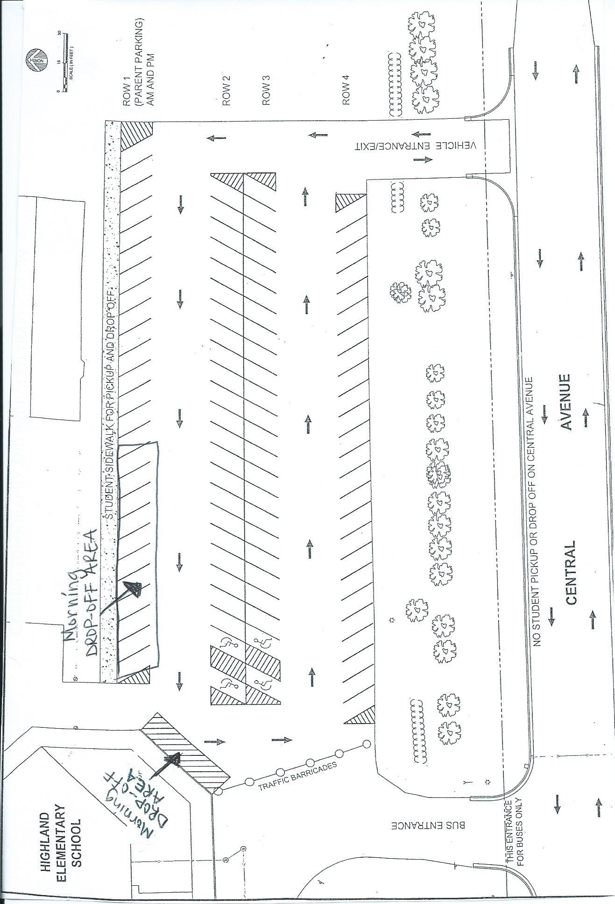

Appendix H: Highland School Discipline Policy

ATTENDANCE
Behaviors | 1st Offense | 2nd Offense | 3rd/Future Offenses
Skipping—leaving class, the school building, or school grounds without a pass. | Parent and student notification. | Alternative Behavioral Intervention Program  and Parent notification. | Alternative Behavioral Intervention Program & Parent/Student meeting
Absenteeism—three (3) or more unexcused absences. | Parent and student notification. | Parent notification. | Alternative Behavioral Intervention Program & Parent/Student meeting
Tardies—(5) unexcused tardies. | Parent and student notification. | Parent notification. | Parent / Student/ Principal Meeting.
With all offenses, building administrators may use discretion in selecting a consequence based on the severity of the offense.

DRESS CODE
Behaviors | 1st Offense | 2nd Offense | 3rd/Future Offenses
Inappropriate Clothing—shorts/skirts that are inappropriate in length; skimpy tank tops (spaghetti straps); exposed midriff; clothing with lewd, vulgar, or obscene messages; apparel promoting illegal products or activities; clothing in violation of community standards; or sexist, racist, or otherwise derogatory messages. | Student will be required to change clothes either school provided or parents will be contacted to provide appropriate clothing. | Student will be required to change clothes either school provided or parents will be contacted to provide appropriate clothing. | Alternative Behavioral Intervention Program & Parent notification.
Headwear—cap, hat, hood  or other headwear deemed inappropriate by principal. | Removal of headwear. | Removal of headwear and headwear stored in the office. | Removal of headwear and headwear stored in office. Habitual violations may lead to parent having to pick up headwear in the office.
With all offenses, building administrators may use discretion in selecting a consequence based on the severity of the offense.

SUBSTANCE & TOBACCO POSSESSION & USE
Behaviors | 1st Offense | 2nd Offense | 3rd/Future Offense
Possession or Use of Alcohol, Tobacco, and Other Drugs—possessing or using any narcotic, inhalants, or controlled substances where possession or use is prohibited by Minnesota or federal law. | Up to 10 days suspension.  Parent notification. | Up to 10 days suspension.  Parent notification. | Expulsion / Exclusion.  Parent notification.
Intent to Distribute Alcohol, Tobacco, or Other Drugs—selling, distributing, or intent to sell alcohol, tobacco, and other drugs. | Up to 10 days suspension.  Parent notification. | 10 days suspension.  Expulsion / Exclusion.  Parent notification. | Expulsion / Exclusion.  Parent notification.
With all offenses, building administrators may use discretion in selecting a consequence based on the severity of the offense.

DAMAGE OR DESTRUCTION TO SCHOOL OR PERSONAL PROPERTY
Behaviors | 1st Offense | 2nd Offense | 3rd/Future Offenses
Vandalism—defacing or damaging property that belongs to the school, students, staff, or anyone involved in school activities. This also includes creating permanent décor to the interior or exterior of lockers. | Possible but not limited to Alternative Behavioral Intervention Program and retribution.  Parent notification.  Possible law enforcement notification. | Possible but not limited to Alternative Behavioral Intervention Program and retribution.  Parent notification.  Possible law enforcement notification.  Possible suspension. | Possible but not limited to Alternative Behavioral Intervention Program and retribution.  Parent notification.  Possible law enforcement notification.  Possible suspension, expulsion, or exclusion.
Misuse of School Books, Supplies, or Equipment—destroying items in any way so as to hamper use by another student. | Replacement costs will be charged to the student.  Parent notification. | Replacement costs will be charged to the student.  Parent notification. | Replacement costs will be charged to the student.  Parent notification.
Tampering with Emergency or Safety Equipment—unauthorized use of emergency or safety equipment on school property or bus including first aid kits, fire extinguishers, and emergency kits, fire extinguishers, and emergency doors or latches. | Possible but not limited to Alternative Behavioral Intervention Program or suspension.  Parent Notification.  Possible law enforcement notification. | Possible but not limited to Alternative Behavioral Intervention Program or suspension up to 10 days.  Parent Notification.  Possible law enforcement notification. | Possible but not limited to Alternative Behavioral Intervention Program or suspension up to 10 days, exclusion, or expulsion.  Parent Notification.  Possible law enforcement notification.
Theft or Possession of Stolen Property—taking or possessing the property of another without right or permission. | Possible but not limited to Alternative Behavioral Intervention Program or suspension.  Parent Notification.  Possible law enforcement notification. | Possible but not limited to Alternative Behavioral Intervention Program or suspension up to 10 days.  Parent Notification.  Possible law enforcement notification. | Possible but not limited to Alternative Behavioral Intervention Program or suspension up to 10 days, exclusion, or expulsion.  Parent Notification.  Possible law enforcement notification.
With all offenses, building administrators may use discretion in selecting a consequence based on the severity of the offense.

VIOLENCE/ABUSE TOWARD OTHERS
Behaviors | 1st Offense | 2nd Offense | 3rd/Future Offenses
Verbal Assault/Abuse—use of direct or indirect abusive, discriminatory, obscene, threatening, or other language intending to provoke or cause fear of bodily harm. | Possible but not limited to Alternative Behavioral Intervention Program.  Parent Notification. | Possible but not limited to Alternative Behavioral Intervention Program or 1-5 days suspension.  Parent Notification.. | Possible but not limited to Alternative Behavioral Intervention Program or 3-10 days suspension.  Parent Notification..
Fighting/Threatening to kill another student—mutual combat in which one or the other party(ies) contributed to the situation by verbal and / or physical action. | Alternative Behavioral Intervention Program  And / Or  1 – 5 days suspension.  Parent Notification. | Alternative Behavioral Intervention Program  And / Or  Up to 10 days suspension, expulsion, or exclusion.  Parent Notification. | Alternative Behavioral Intervention Program  And / Or  Up to 10 days suspension, expulsion, or exclusion.  Parent Notification.
Firearms Possession—any firearm, whether loaded or unloaded, including BB and pellet guns, in school zone. | 10 days suspension.  Expulsion / Exclusion.  Parent Notification. | Expulsion / Exclusion.  Parent Notification. | Expulsion / Exclusion.  Parent Notification.
Laser Pointers | Device will be taken from student possession and held in the office until parents are able to pick them up. Parent Notification. | Device will be taken from student possession and held in the office until parents are able to pick them up. Parent Notification. | Alternative Behavioral Intervention Program  And / Or  1 – 5 days suspension.  Parent Notification.
With all offenses, building administrators may use discretion in selecting a consequence based on the severity of the offense.

INSUBORDINATION
Behaviors | 1st Offense | 2nd Offense | 3rd/Future Offenses
Insubordination—willful refusal to follow any direction or order by a staff member. | Possible but not limited to Alternative Behavior Program.  Parent Notification. | Alternative Behavioral Intervention Program  And / Or  Possible 1 day suspension.  Parent Notification. | Alternative Behavioral Intervention Program  And / Or  1 – 3 days suspension.  Parent Notification.
Profanity / Obscenity— verbal abuse, profanity, or obscenity directed at a staff member or student. | Possible but not limited to Alternative Behavior Program.  Parent Notification. | Alternative Behavioral Intervention Program  And / Or  Possible 1 day suspension.  Parent Notification. | Alternative Behavioral Intervention Program  And / Or  1 – 3 days suspension.  Parent Notification.
Disruption to School—disrupting a school activity by shouting, throwing items, spitting, or other rude behavior. | Possible but not limited to Alternative Behavior Program.  Parent Notification. | Alternative Behavioral Intervention Program  And / Or  Possible 1 day suspension.  Parent Notification. | Alternative Behavioral Intervention Program  And / Or  1 – 3 days suspension.  Parent Notification.
Academic Dishonesty— including but not limited to cheating individually or with another student to take credit for work that is not their own, unapproved test or information access, and plagiarism. | Possible but not limited to Alternative Behavior Program.  Parent Notification. | Alternative Behavioral Intervention Program  And / Or  1 – 3 days suspension.  Parent Notification. | Alternative Behavioral Intervention Program  And / Or  3 – 10 days suspension.  Parent Notification.
Harassment and Bullying—participating in or conspiring with others to engage in acts that degrade, intimidate, or disgrace other individuals, including indecent exposure and words or actions that negatively impact an individual or groups based on their racial cultural or religious background, their sex or any disability they may have. | Possible but not limited to Alternative Behavior Program.  Parent Notification. | Alternative Behavioral Intervention Program  And / Or  1 – 3 days suspension.  Parent Notification. | Alternative Behavioral Intervention Program  And / Or  Up to 10 days suspension. Expulsion / Exclusion.  Parent Notification.
Unauthorized Use of Equipment—use of headsets, cell phones, video games, pagers, rollerblades, skate boards, hacky sack, cards, etc. | Possible but not limited to Alternative Behavior Program.  Parent Notification  Parent Must Retrieve Device. | Habitual violations may lead to suspension.  Parent Notification.  Parent Must Retrieve Device. | Habitual violations may lead to suspension.  Parent Notification.  Parent Must Retrieve Device.
Throwing Objects to / from Vehicles—throwing any items inside a bus, from outside a bus to inside a bus, or from inside a bus to outside a bus. | Possible but not limited to Alternative Behavior Program.  Parent Notification.Parent Notification. | Alternative Behavioral Intervention Program  And / Or  Suspension from bus for 1 – 5 days.  Parent Notification. | Parent notification.  Privilege to ride bus revoked.  Parent Notification.
Food Fight at School  Any student involved in a food fight (throwing food). | 1-3 days suspension.  Law enforcement will be called.  Student required to eat lunch in the office remainder of the year.  Parent notification. | 1-5 days suspension.  Law enforcement will be called.  Student required to eat lunch in the office remainder of the year.  Parent notification. | 1-10 days suspension.  Law enforcement will be called.  Student required to eat lunch in the office remainder of the year.  Parent notification.
With all offenses, building administrators may use discretion in selecting a consequence based on the severity of the offense.

RECESS
Behaviors | 1st Offense | 2nd Offense | 3rd/Future Offenses
Not following recess rules | Possible loss of recess 1-5 days. | Possible loss of recess 1-3 weeks.  Parent Notification. | Possible loss of recess the rest of the year.  Parent Notification.
With all offenses, building administrators may use discretion in selecting a consequence based on the severity of the offense.

Appendix I: Parent Refusal for Student Participation in Statewide Assessments
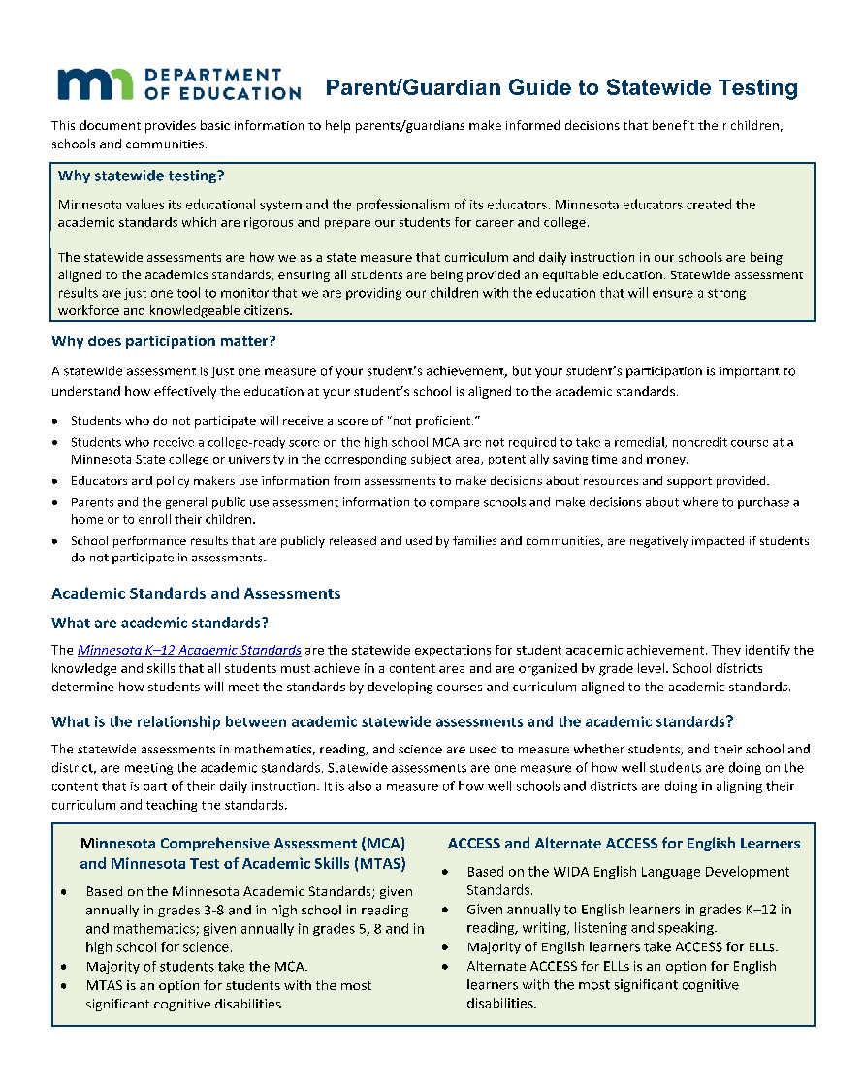
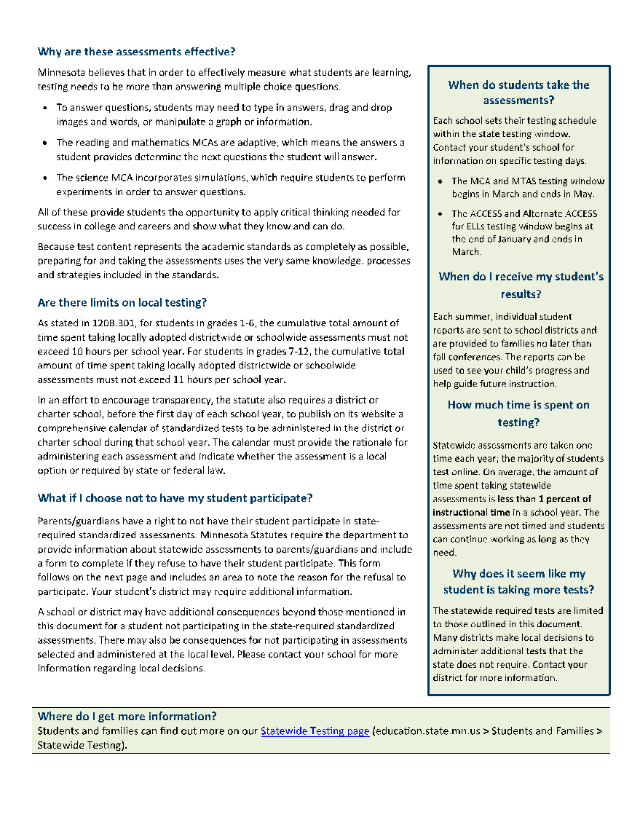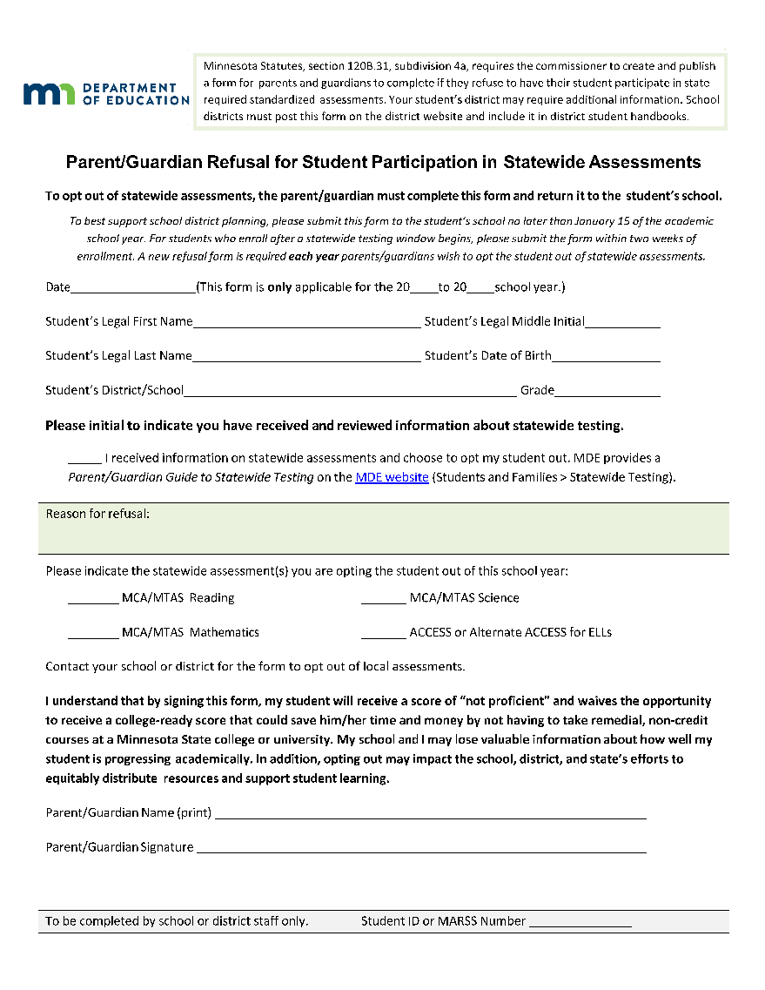

Appendix J: Highland School Calendar 2022-23

August | 30 | Workshop Day
 | 31 | Workshop Day
September | 1 | Workshop Day
 | 2 | Compensation Day
 | 5 | No School- Labor Day
 | 6 | First Day of School
October | 18 | Regular Dismissal- Parent/Teacher Conferences 4:00-7:30pm
 | 19 | No School- Parent/Teacher Conferences 8:00-7:30
 | 21 | No School Compensation Day
 | 31 | No School – Staff Development Day
November | 4 | End Qtr 1 (41 days)
 | 24 & 25 | No School- Thanksgiving
December | 22-30 | No School- Winter Break
January | 1-2 | No School – Winter Break
 | 16 | No School- Workshop Day
 | 27 | End Qtr 2 (44 days)
February | 15 | Regular Dismissal- Parent/Teacher Conferences 4:00-7:30pm
 | 16 | No School- Parent/Teacher Conferences 8:00-7:30
 | 17 | No School Compensation day
 | 20 | No School- Presidents Day
March | 20 | NO School- Staff Development Day
 | 24 | End Qtr 3 (42 days)
April | 7-10 | No School- Spring Break
May | 26 | Graduation
 | 29 | No School- Memorial Day
June | 1 | Last Day of School- End Qtr 4 (45 days)
 | 2 | Workshop Day

Appendix K: Student Placement Request

Date Received _______________________
Student Placement Request: If you choose to request special placement for your child, please complete this form and return to the school office no later than April 14th. Requests received after the April 14th deadline will not be accepted.

Student Placement Request by Parent

Child’s Name: ____________________________________Date: _____________________

Grade Level Next Year: _________Parents: ______________________________________

In order to help with your child’s placement, please fill out this form COMPLETELY.

- What are the educational reasons for making this special request?

- Teacher Request - Please list 3 teachers or your request will be denied. Although you are not guaranteed your choice, every attempt will be made to honor one of the three requests.

1st______________________________________________________________________

2nd______________________________________________________________________

3rd______________________________________________________________________

3. Are there any students your son/daughter should not be with, due to special circumstances? Please list student and reason. (This may include relatives in same grade, neighbors, etc.).

(Parent/Guardian Signature)

Fecha Recibida ________________________
Solicitud Para El Estudiante: Si decide solicitar la colocación especial para su hijo, por favor complete este formulario y devuélvalo a la oficina de la escuela a más tardar el 14 de abril. No se aceptarán las solicitudes que se reciban después de la fecha límite de 14 de abril. Al realizar la solicitud, comprenda que pueda obtener su primera o segunda solicitud según la disponibilidad. A ningún padre se le permite solicitar donde debe estar el hijo de otro padre.

Solicitud Para El Estudiante Pedida Por Padres.

Estudiante: ______________________________________Fecha: ______________________

Grado Para El Proximo Ano: ________Padre(s): ____________________________________

- Cuales son las razones educacionales para pedir esta solicitud especial?

2. Maestro/a-Solicitudo Favor de poner 3 nombres de los maestros que quiere solicitar (o) su pedido sera negado. Se va a ser todo lo posible por complacer uno de su 3 pedidos. Pero no se le garantiza.

- __________________________________________________

- __________________________________________________

- __________________________________________________

3. Ya algunos estudiantes con los que su hijo/hija no debido a circumstancias especials? (esto incluye que sean familiares, amigos, vecinos, etc.) Ponga los nombres y razones.

Firma de Padres

Appendix L: Medication Administration Authorization Form

Appendix N: School Volunteer/Chaperone Form

THIS
PAGE
LEFT
BLANK
INTENTIONALLY

